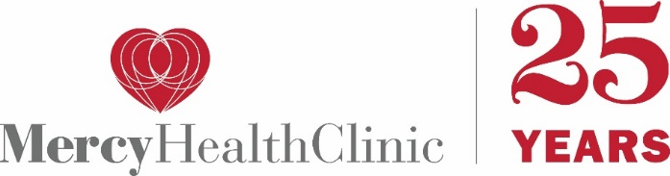

2025 Heart of Mercy Gala
Honoring Our Legacy . . . Celebrating Our Community . . . Building Our Future
Friday, March 28, 2025
In 2024 Mercy Health Clinic served 2,450 low-income residents of Montgomery County, MD providing both primary and specialty medical care, health education and medications to patients free of charge. This year at our annual fundraising gala we will be celebrating our 25th Anniversary of service to the community changing the lives of 20,000 patients over those years who would otherwise not have been able to afford healthcare.
Please donate a gift certificate or item to the gala silent auction in recognition of this milestone and in support of community health protecting us all. Your support is greatly appreciated.

Donor Name or Company:_______________________________________________________
Credit in Item Display and/or Program to Read:______________________________________
Address:_____________________________________________________________________
Telephone:_________________________ Email:____________________________________

Item Name:___________________________________________________________________
Description: __________________________________________________________________
____________________________________________________________________________
Dollar Value*_____________ Restrictions/Deadlines:_________________________________

Donor Signature:________________________________________ Date:_________________

Received by: ______________________________________________ for Mercy Health Clinic

Please send auction contributions to:
Mercy Health Clinic, 7 Metropolitan Court, Suite 1, Gaithersburg, MD 20878 or contact Joan Ronnenberg
at joan.ronnenberg@mercyhealthclinic.org or 240-308-2431

* Mercy Health Clinic is not qualified to and does not estimate the fair market value of donated items.
Values given are those provided by the donor. Donations may be reviewed by the gala committee.

Mercy Health Clinic is a non-profit, 501(c)(3) tax-exempt organization federal tax ID# 52-2230932
No goods or services were exchanged for the contribution. This gift is tax deductible as allowed by law.

